High Power 10 Pin Connector

(Stage Connector)

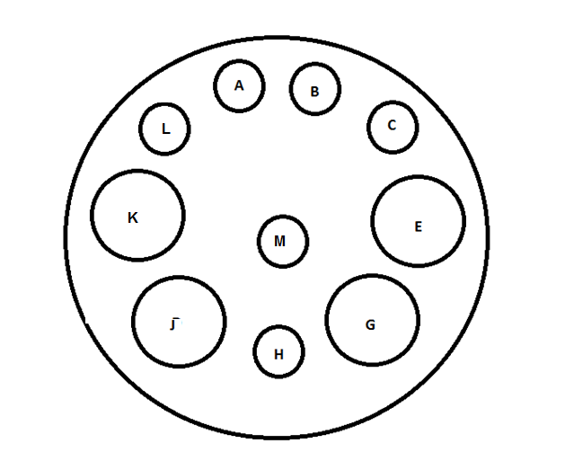

|  |  |  |
| --- | --- | --- |
| Pin # | Description | Wire Color(Gauge) |
| Pin A | RTD+ (red) | Red |
| Pin B | RTD- (white) | Black |
| Pin C | RTD- (white) | Black |
| Pin E | TE+ (1) | RED(14) |
| Pin G | TE- (1) | Black(14) |
| Pin H | Bimetallic | Purple(20) |
| Pin J | TE- (2) | Black(14) |
| Pin K | TE+ (2) | RED(14) |
| Pin L | Ground | Green (16) |
| Pin M | Bimetallic | Purple(20) |